**Three major features of VSCode**

**Logan Hiller**

These features of VSCode will be helpful to juniors during this course. The directions for each feature will go step by step so that it is easier to understand and execute properly.

1. Tutorials

On the first time you open VSCode, you are greeted to the “Get Started” page where you can create a new file or open an existing file, open a folder, or clone a Git repository. There is also a section on the screen where you can open recent documentations. On the right of the screen, there is a tab with walkthroughs. You can click on them or select the “More…” option to see all the available tutorials. There are three different tutorials to choose from, like Getting Started with VS Code, Learning the Fundamentals of VS Code, and Boosting your productivity in VS Code.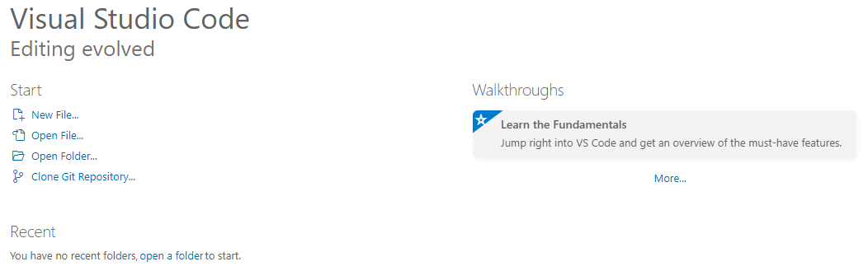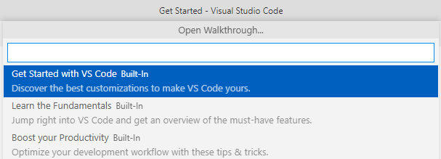

1. Interactive Editor Playground

In the “Learn the Fundamentals” tutorial, or if you hover over the “Help” tab, you can find the Interactive Editor Playground. The Playground covers many things about the core editor in VS Code, and lets you interactively try them through the use of a number or embedded editors. The Playground shows many different things like Multi-Cursor Editing, IntelliSense, Line Actions, Code Folding, and more.

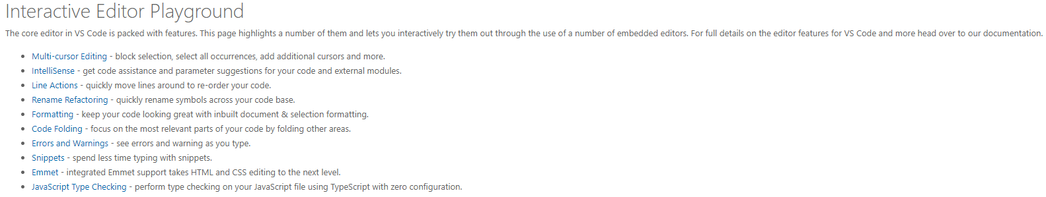

1. Command Palette and Keyboard Shortcuts

On the bottom left of the screen, you can find a settings icon in the shape of a gear. If you click it, you can find two important features that can assist you with coding, the Command Palette and Keyboard Shortcuts. In the Command Palette, you can find multiple functions to assist you with VS Code, like debugging, developer, and Github commands. You can also find a list of Keyboard Commands that can help you with your coding, like using a terminal, organizing imports, or changing the language. Both the Command Palette and Keyboard Command lists can be edited to fit your needs and make executing them more comfortable. On the Command Palette, hover over the command you want to edit, click the gear icon, and then double click the command to enter the key bindings you want. For the Keyboard Commands, you don’t need to click on a gear. Just double click the command and edit the bindings. 